

Term Work

# On

CBNST

# (PMA 502)

## Submitted to: Submitted by:

Ms. Preeti Chaudhary < Vishal Joshi> Assistant Professor University Roll. No.: 2018861 GEHU, D. Dun Class Roll No./Section: 63/A

### DEPARTMENT OF COMPUTER SCIENCE AND ENGINEERING

GRAPHIC ERA HILL UNIVERSITY, DEHRADUN

**List of Programs**

|  |  |  |  |
| --- | --- | --- | --- |
| **S.No** | **Name of Program** | **Date** | **Remark** |
| 1. | Write a program in “C” Language To deduce error involved in polynomial equation. |  |  |
| 2. | Write a program in “C” Language to find out the root of the Algebraic and Transcendental equations using Bisection Method. |  |  |
| 3. | Write a program in “C” Language to find out the root of the Algebraic and Transcendental equations using Regula Falsi Method. |  |  |
| 4. | Write a program in “C” Language to find out the root of the Algebraic and Transcendental equations using Newton Raphson Method. |  |  |
| 5. | Write a program in “C” Language to find out the root of the Algebraic and Transcendental equations using Iteration Method. |  |  |
| 6. | Write a program in “C” Language to find out the root of the Algebraic and Transcendental equations using Secant Method. |  |  |
| 7. | Write a program in “C” Language to find the solution of Linear Equation using Gauss Elimination Method. |  |  |
| 8. | Write a program in “C” Language to find the solution of Linear Equation using Gauss Jordan Method. |  |  |
| 9. | Write a program in “C” Language to find the solution of Linear Equation using Gauss Seidel Method. |  |  |
| 10. | Write a program in “C” Language to interpolate numerically using Newton Forward Difference Method. |  |  |
| 11. | Write a program in “C” Language to interpolate numerically using Newton Backward Difference Method. |  |  |
| 12. | Write a program in “C” Language to interpolate numerically using Lagrange’s Method. |  |  |
| 13. | Write a program in “C” Language to integrate numerically using Trapezoidal Rule. |  |  |
| 14. | Write a program in “C” Language to integrate numerically using Simpson’s 1/3 Rule. |  |  |
| 15. | Write a program in “C” Language to integrate numerically using Simpson’s 3/8 Rule. |  |  |
| 16. | Write a program in “C” Language to find the numerical solution of ordinary differential equations by Euler’s Method. |  |  |
| 17. | Write a program in “C” Language to find the numerical solution of ordinary differential equations by Runge Kutta (Order 4) Method. |  |  |
| 18. | Write a program in “C” Language for Linear Curve Fitting. |  |  |
| 19. | Write a program in “C” Language for Parabolic Curve Fitting. |  |  |
| 20. | Write a program in “C” Language for finding out the Regression Lines. |  |  |

Output 1:

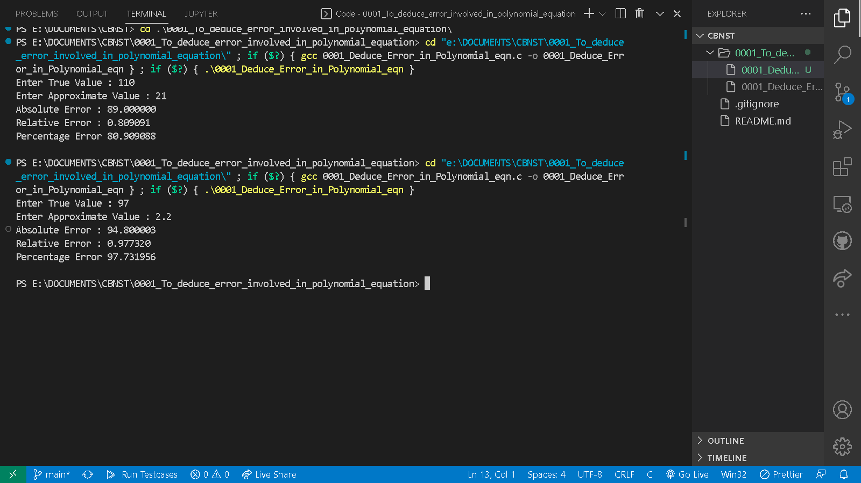

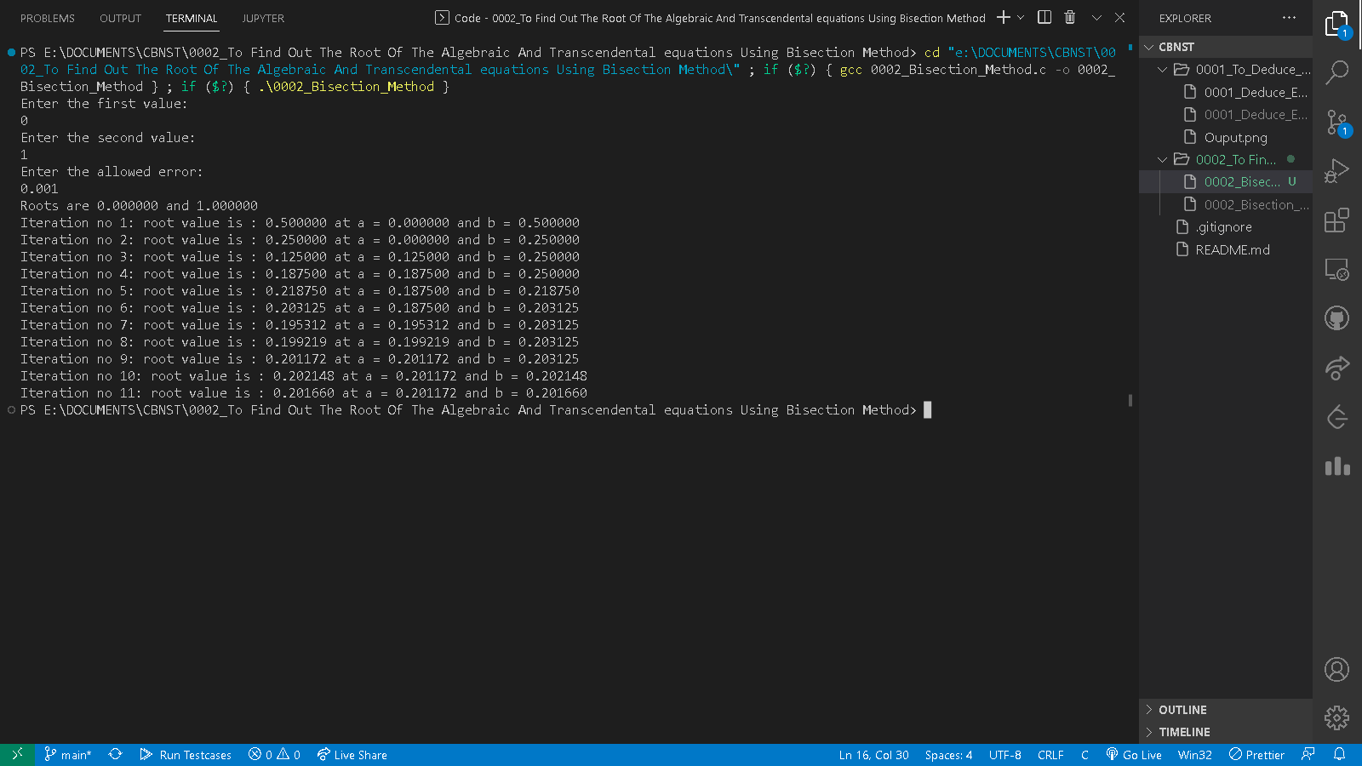Output 2:

Output 3:

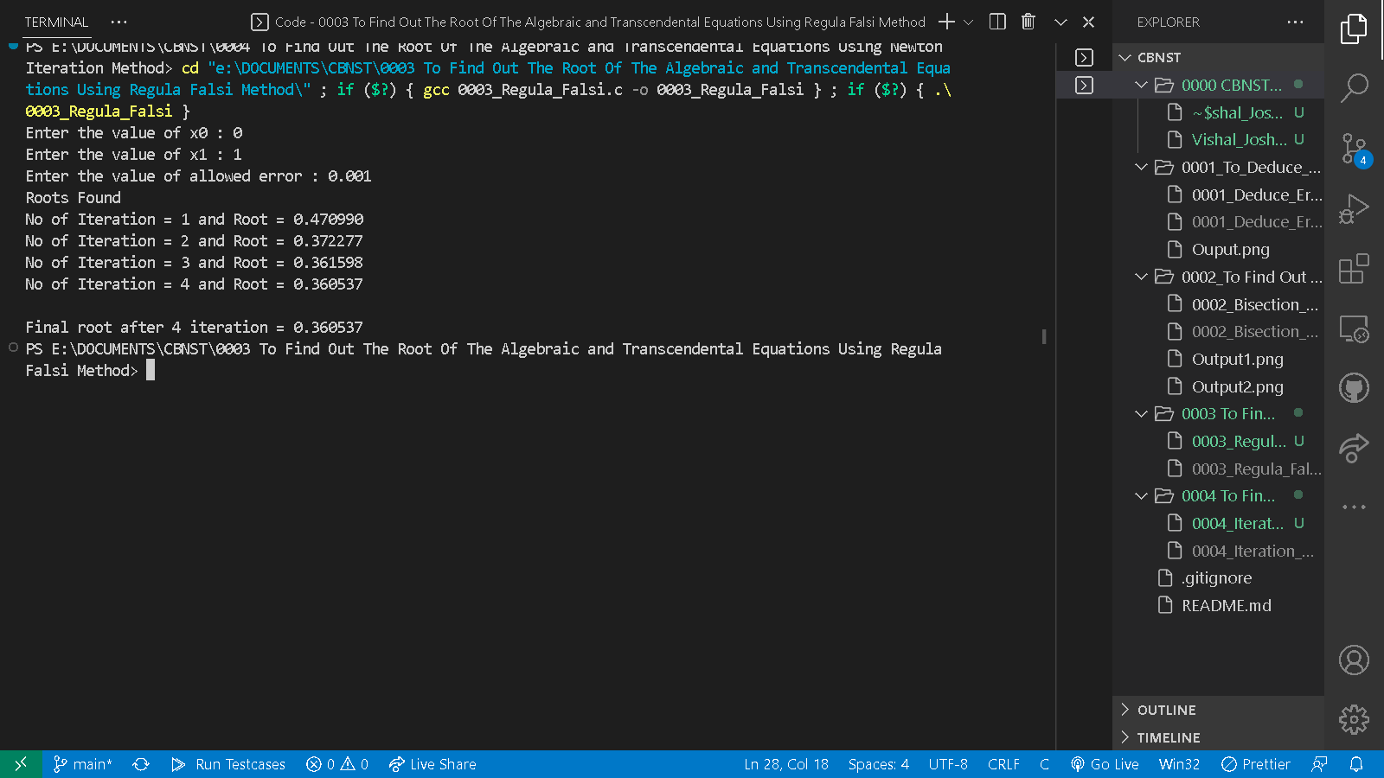

Output 4:

